EPAM University Programs   
DevOps external course   
Module 4 DevOps Introduction   
TASK 4.2

1. Set up Linux Virtual Machine in VirtualBox.   
2. Familiarize yourself with the commands and utilities listed in the presentation (switching between virtual terminals (consoles); printenv; content of /etc/profile and ~/.bash_profile, $echo $HISTFILE $HISTSIZE $HISTFILESIZE, who, w, whoami, id). Make 5 screenshots.

Switching on terminal 3

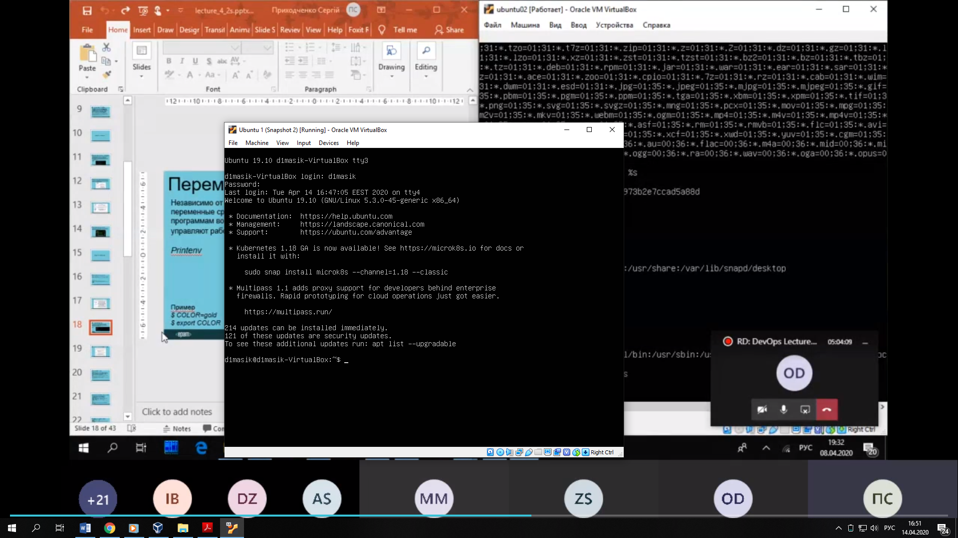

printenv – shows variables of environment

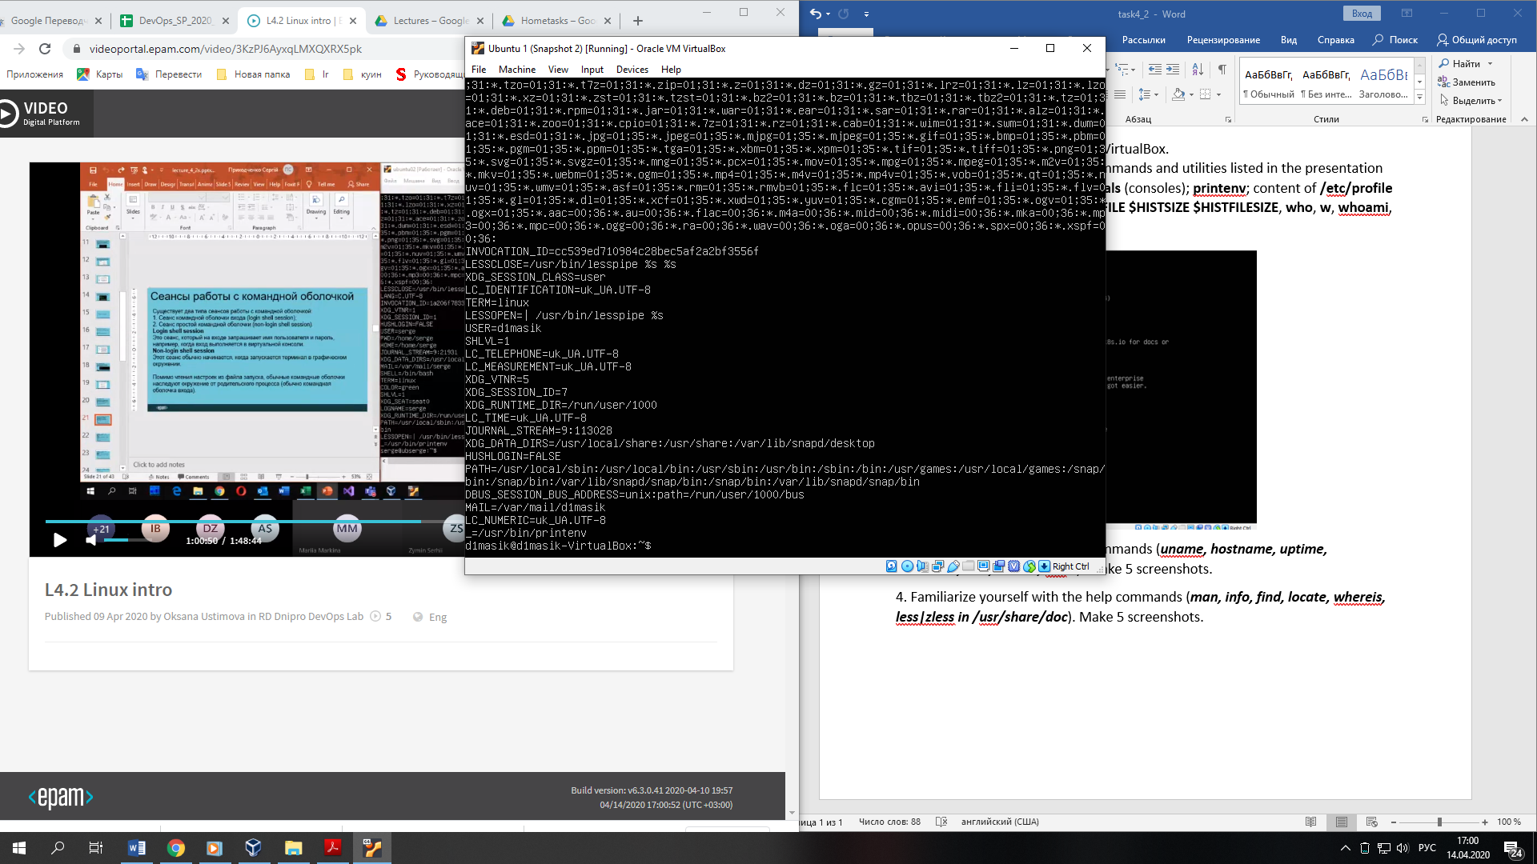

echo $HISTFILE $HISTSIZE $HISTFILESIZE – shows path file of history, number of commands which saved in HISTFILE and not more than HISTFILESIZE strings

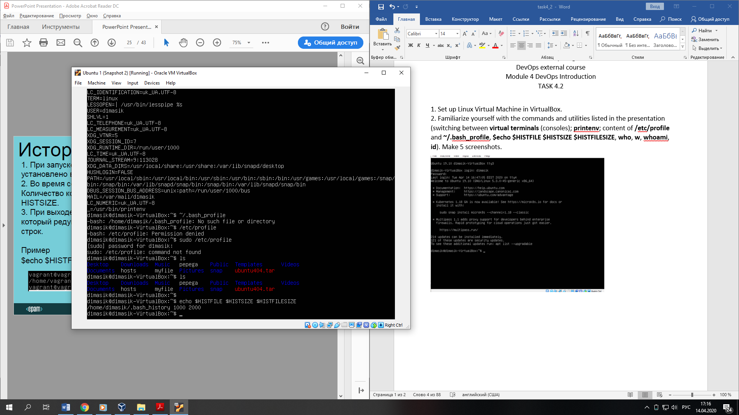

who(whoami) – print who is currently logged in.

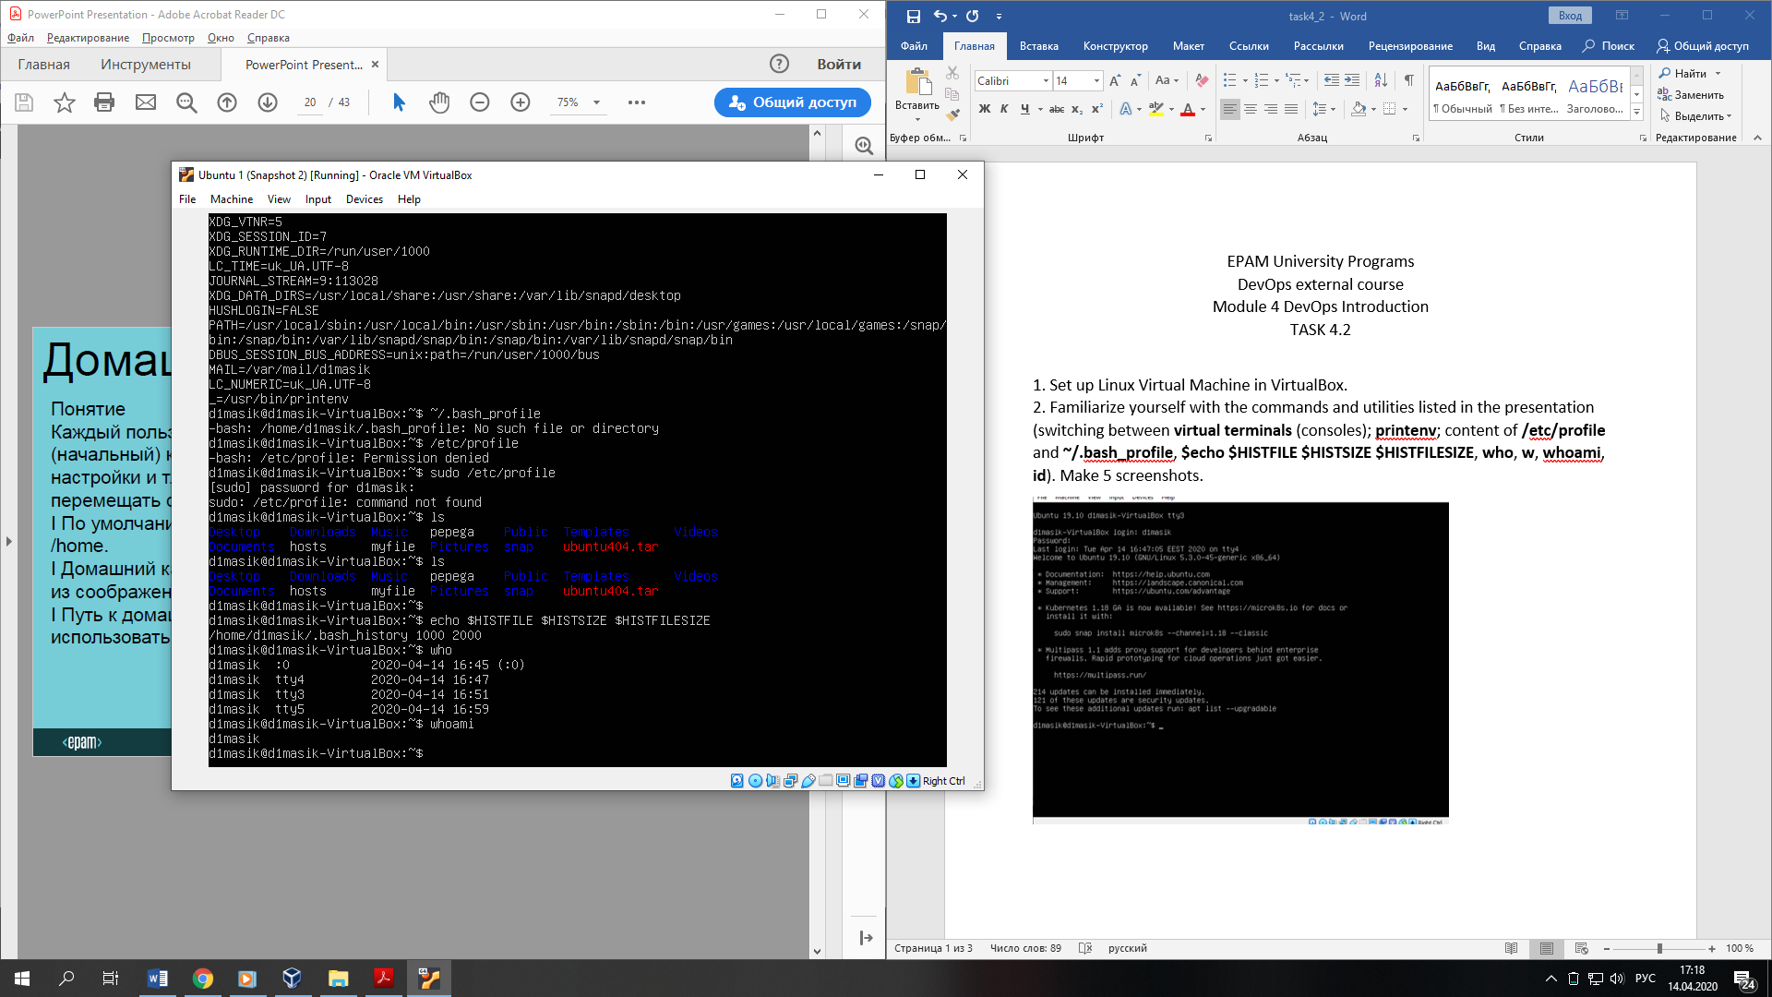

id – prints identity information about the given user

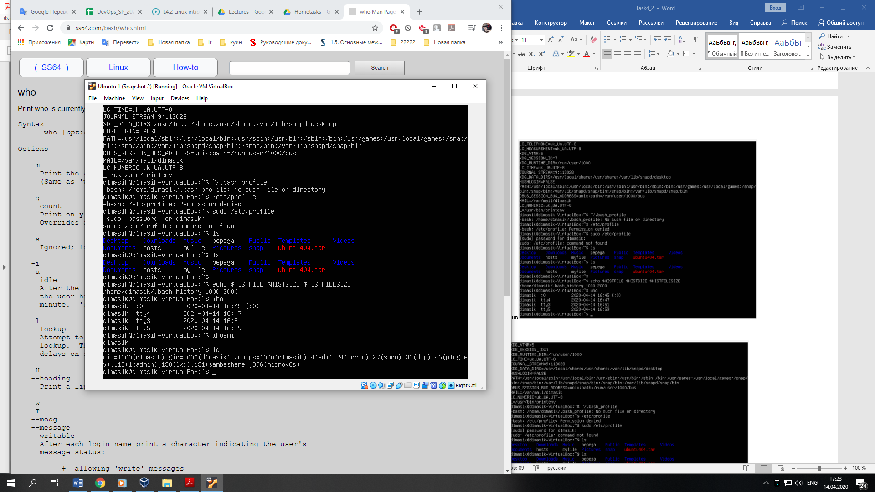

3. Familiarize yourself with the commands (***uname, hostname, uptime, shutdown, halt, reboot, init…***). Make 5 screenshots.

uname – print system information about machine and operating system it is run on.

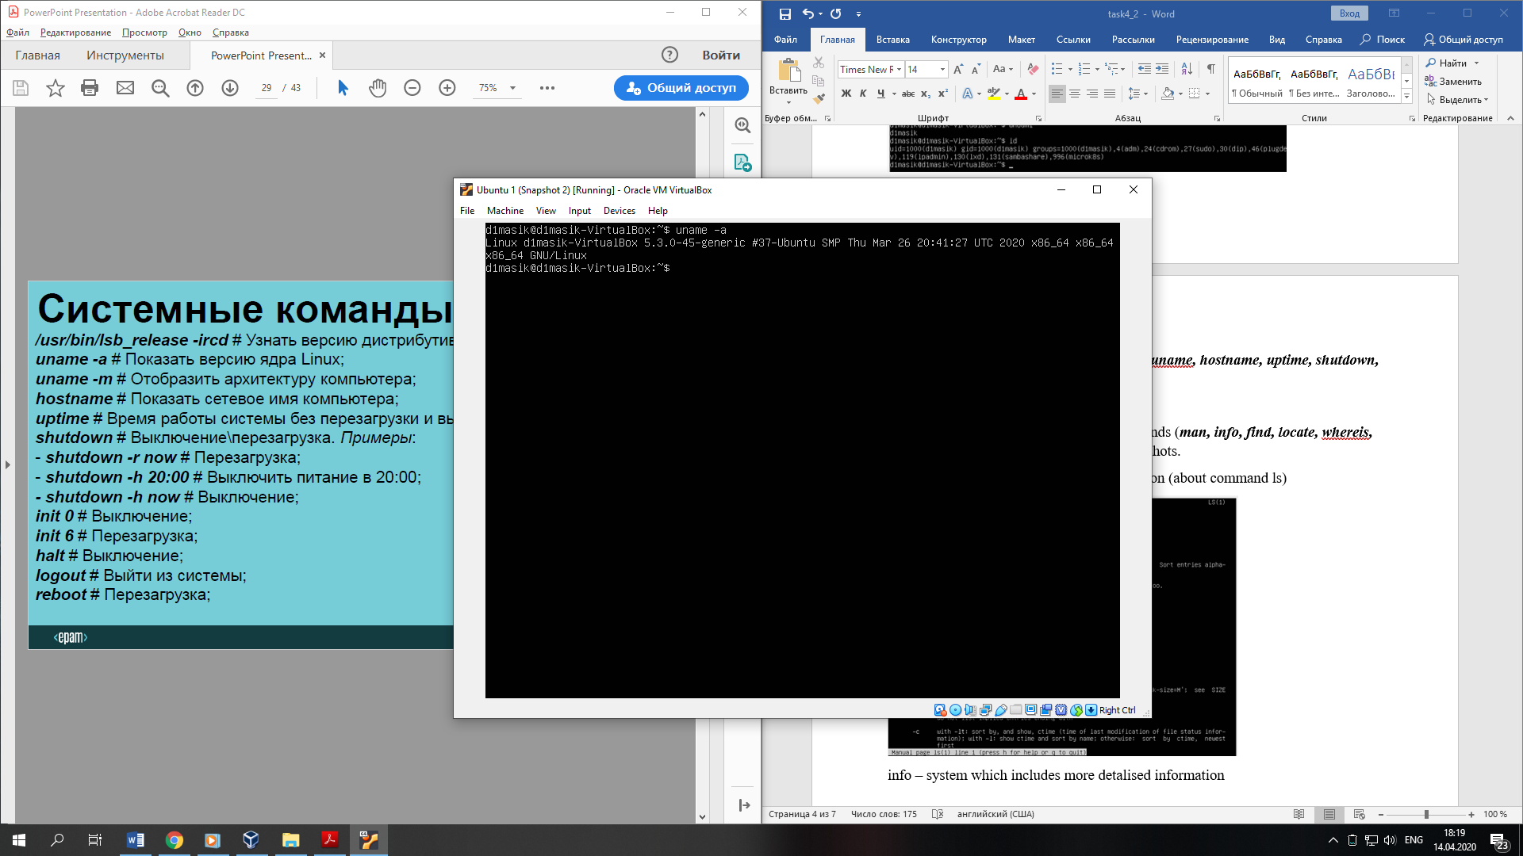

hostname – shows the networking name of computer

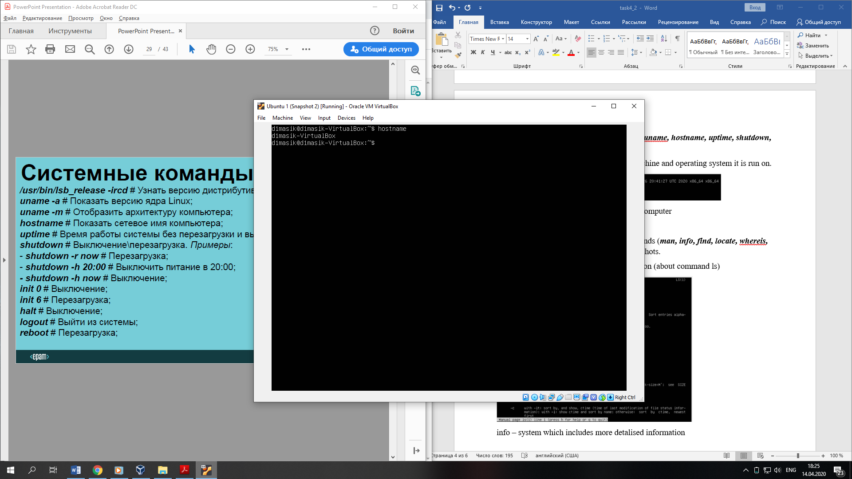

uptime – shows operating time without rebooting or shutdown

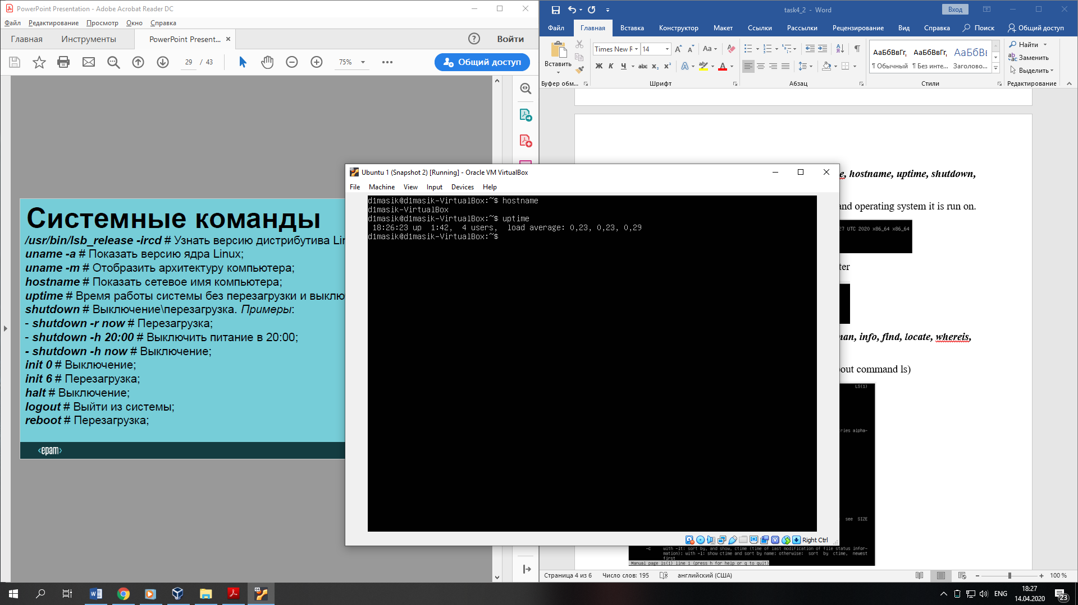

shutdown – rebooting or shutdown operating system

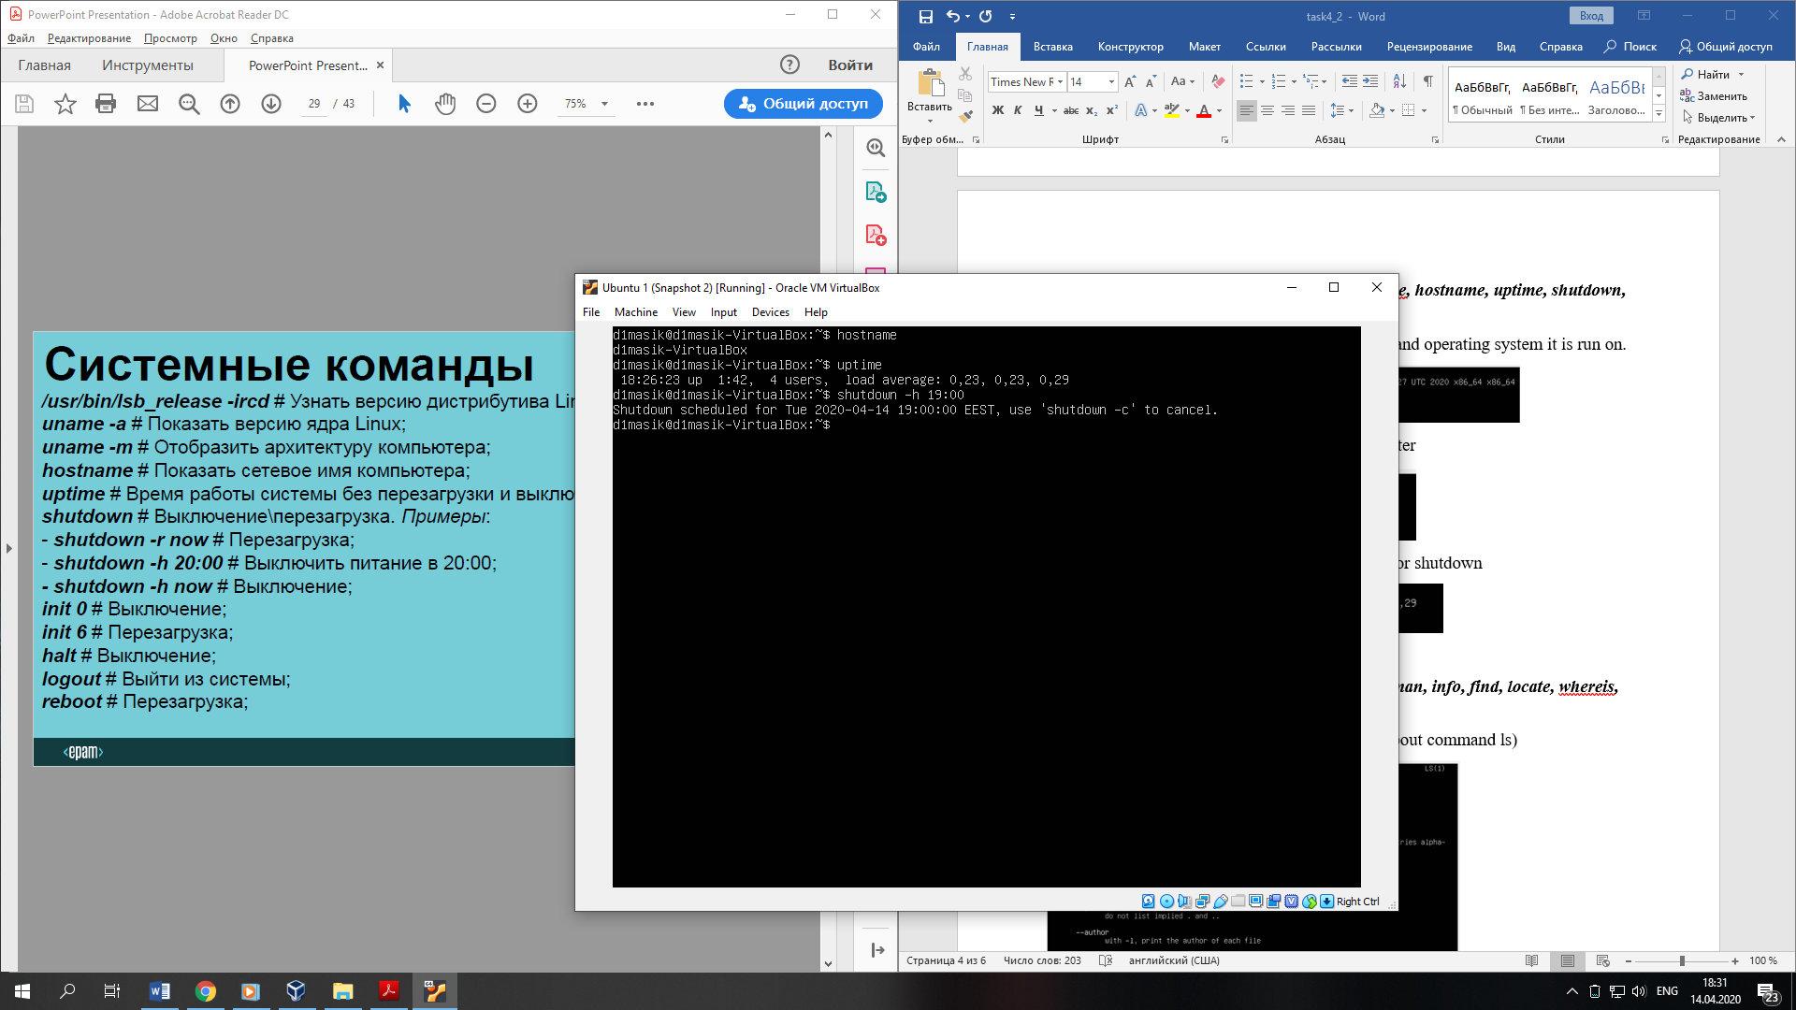

reboot – rebooting operating system

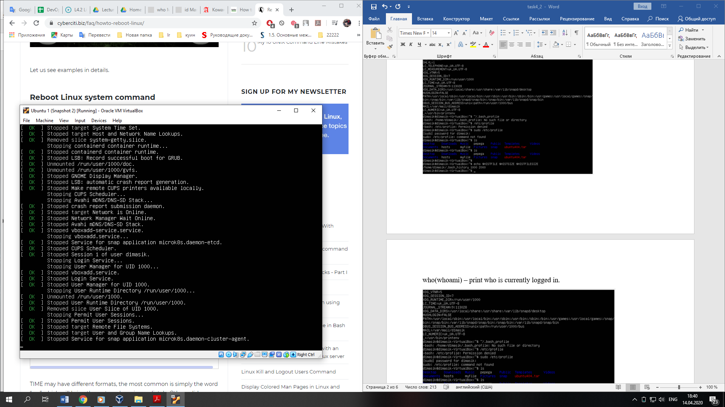

4. Familiarize yourself with the help commands (***man, info, find, locate, whereis, less|zless in /usr/share/doc***). Make 5 screenshots.

man – shows pages with reference information (about command ls)

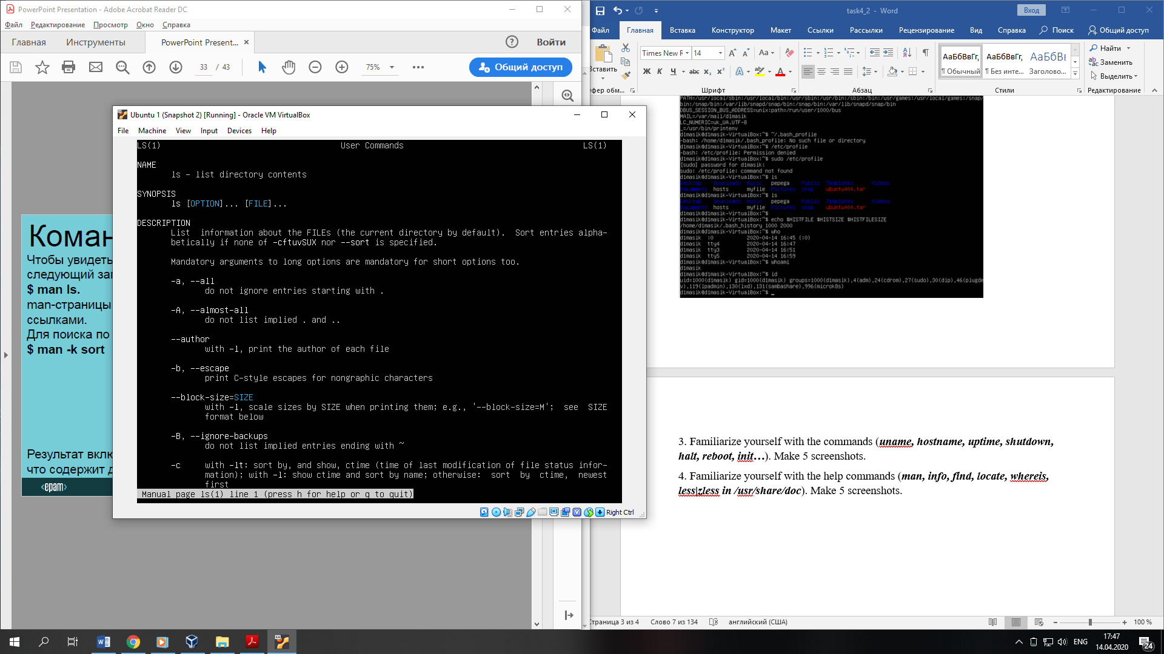

info – system which includes more detalised information

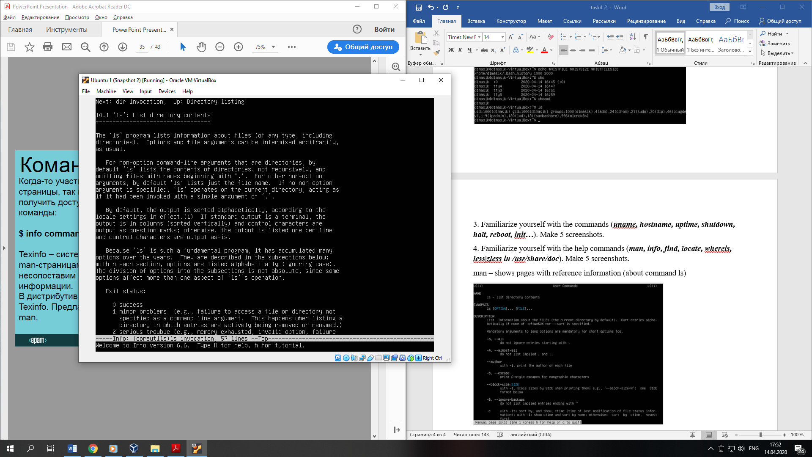

find – search file (by name in a particular case)

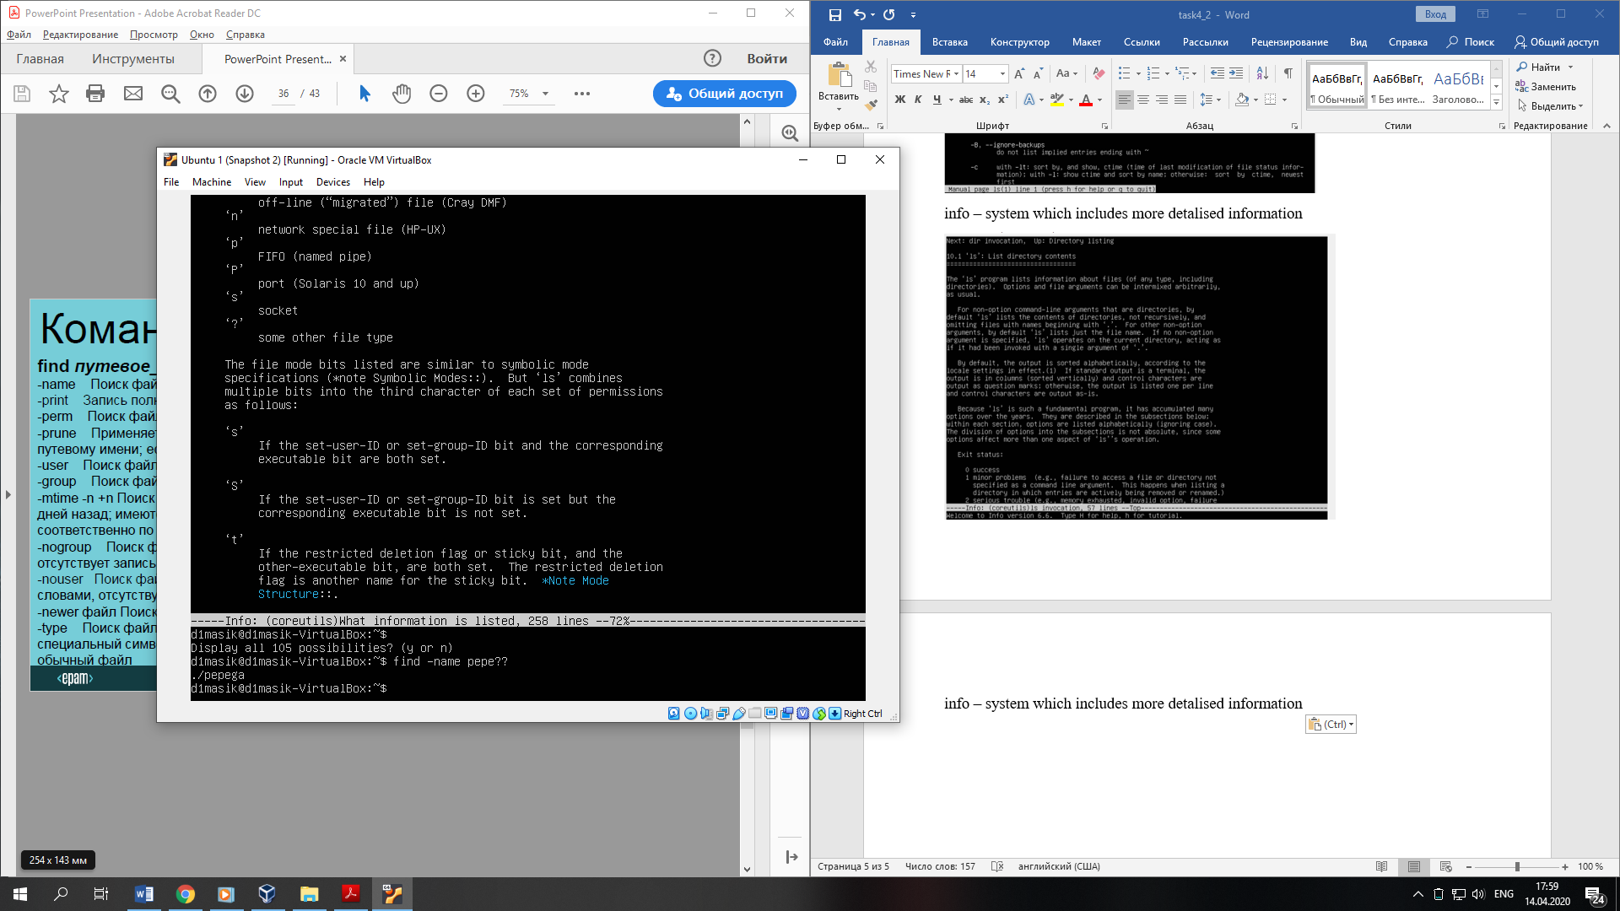

locate – shows path of file

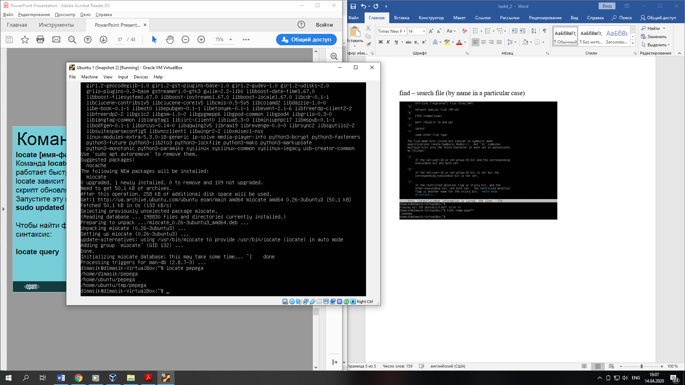

whereis – searches path binary, source and reference files for this command

